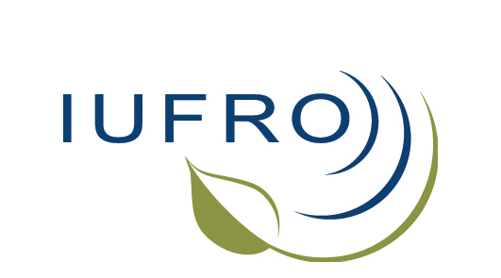
Press Release
International Union of Forest Research Organizations

IUFRO appoints Mike Wingfield as new President

Niels Elers Koch handed over IUFRO Presidency today
at the 24th IUFRO World Congress in Salt Lake City, Utah, USA

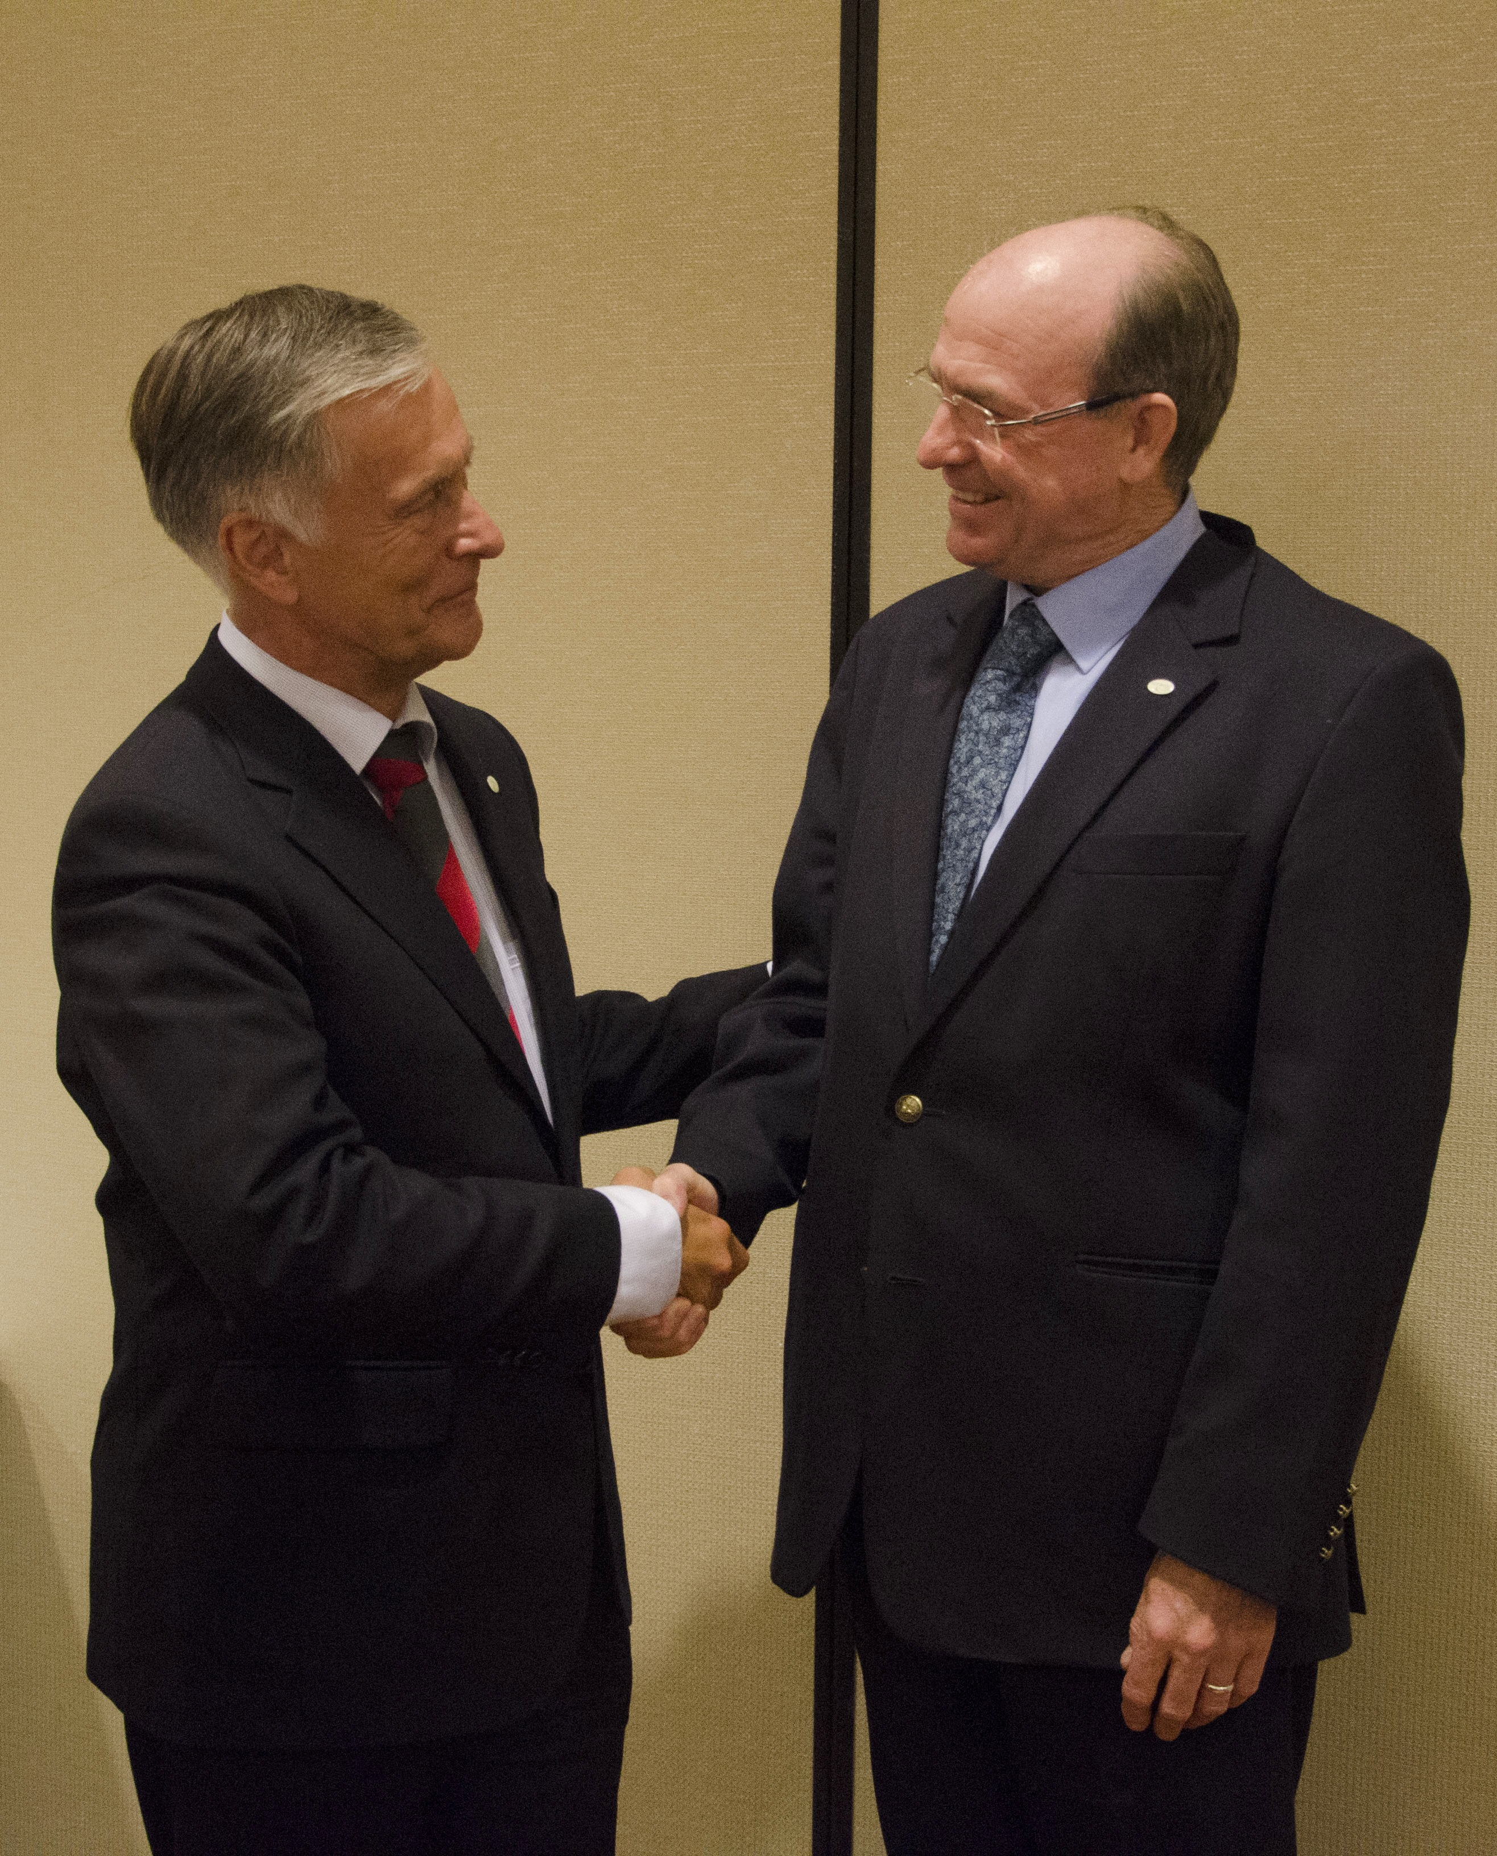
10 October 2014, Salt Lake City/Vienna – The International Union of Forest Research Organizations (IUFRO) today announced the appointment of Prof. Mike Wingfield as new President. IUFRO’s International Council elected him during a meeting at the 24th IUFRO World Congress, which is currently taking place in Salt Lake City, Utah, United States. Mike Wingfield follows Prof. Niels Elers Koch who served IUFRO – the only worldwide organization devoted to forest research and related sciences – as President for the past four years.

“We successfully strengthened global networking in forest science served by a well-functioning IUFRO Headquarters, Board and Management Committee. Furthermore we held the first-ever IUFRO Regional Congress for Africa in 2012 in Kenya and another IUFRO Regional Congress in Latin America in 2013 in Costa Rica”, said Niels Elers Koch summarizing some of IUFRO’s major achievements during his time as President. He also noted with pleasure a strengthened collaboration with the International Forestry Students' Association, IFSA, among other global alliances.
IUFRO’s immediate past President Niels Elers Koch, Denmark (left) with newly elected IUFRO President Mike Wingfield, South Africa. (Photo by Ramin Khorchidi/IUFRO)

Mike Wingfield, IUFRO’s incoming President, said “Much as IUFRO has enriched my life so deeply, it is my wish that the same will be true, particularly for the many young forest scientists in the world”. He particularly highlighted IUFRO’s special relationship with IFSA and his commitment to build this bond as actively as possible in the future. Furthermore, he referred to IUFRO’s great responsibility as the global network for forest research “to provide solid and reliable data that will underpin some of the most important decisions relating to our fragile and highly threatened world. He added, ”Never before has the world relied so heavily on its natural resources and forestry links these resources in every possible way.” He underlined the essential role of forests for a sustainable future of our planet.

Michael (Mike) Wingfield, Professor and Founding Director of the Forestry and Agricultural Biotechnology Institute (FABI) of the University of Pretoria (South Africa) has been involved in IUFRO activities for more than 30 years. He has served as IUFRO Vice President in the 2010-2014 Board Term. As a researcher, he is broadly interested in the health of trees and has conducted research on tree pests and pathogens. He is a fellow of various scientific societies including the Royal Society of South Africa and the American Phytopathological Society. He has received honorary doctorates from the University of British Colombia, Canada, and North Carolina State University and received the highest scientific award (Kwame Nkrumah Scientific Award) from the African Union in 2013.

The 24th IUFRO World Congress “Sustaining Forests, Sustaining People: The Role of Research” (http://iufro2014.com/) aims at showcasing the scientific expertise and activities in current forest research to address the range of sustainability challenges and opportunities. The Conference is being held until the 11th of October in Salt Lake City, Utah, United States. It is organized by the International Union of Forest Research Organizations (IUFRO) and hosted by the U.S. Department of Agriculture Forest Service in cooperation with the National Association of University Forest Resources Programs (NAUFRP), the Society of American Foresters (SAF), and the Canadian Institute of Forestry (CIF/IFC).

Media contact:
Gerda Wolfrum, International Union of Forest Research Organizations (IUFRO), wolfrum@iufro.org

The International Union of Forest Research Organizations (IUFRO) is the only worldwide organization devoted to forest research and related sciences. Its members are research institutions, universities, and individual scientists as well as decision-making authorities and other stakeholders with a focus on forests and trees. www.iufro.org

24th IUFRO World Congress 2014
5 – 11 October 2014, Salt Lake City, Utah, USA
Congress website: http://iufro2014.com/
Media and News: http://iufro2014.com/news/

Media contact:
Gerda Wolfrum, International Union of Forest Research Organizations (IUFRO), wolfrum@iufro.org

The International Union of Forest Research Organizations (IUFRO) is the only worldwide organization devoted to forest research and related sciences. Its members are research institutions, universities, and individual scientists as well as decision-making authorities and other stakeholders with a focus on forests and trees. www.iufro.org

