DAVID ALAN READ

Curriculum vitae

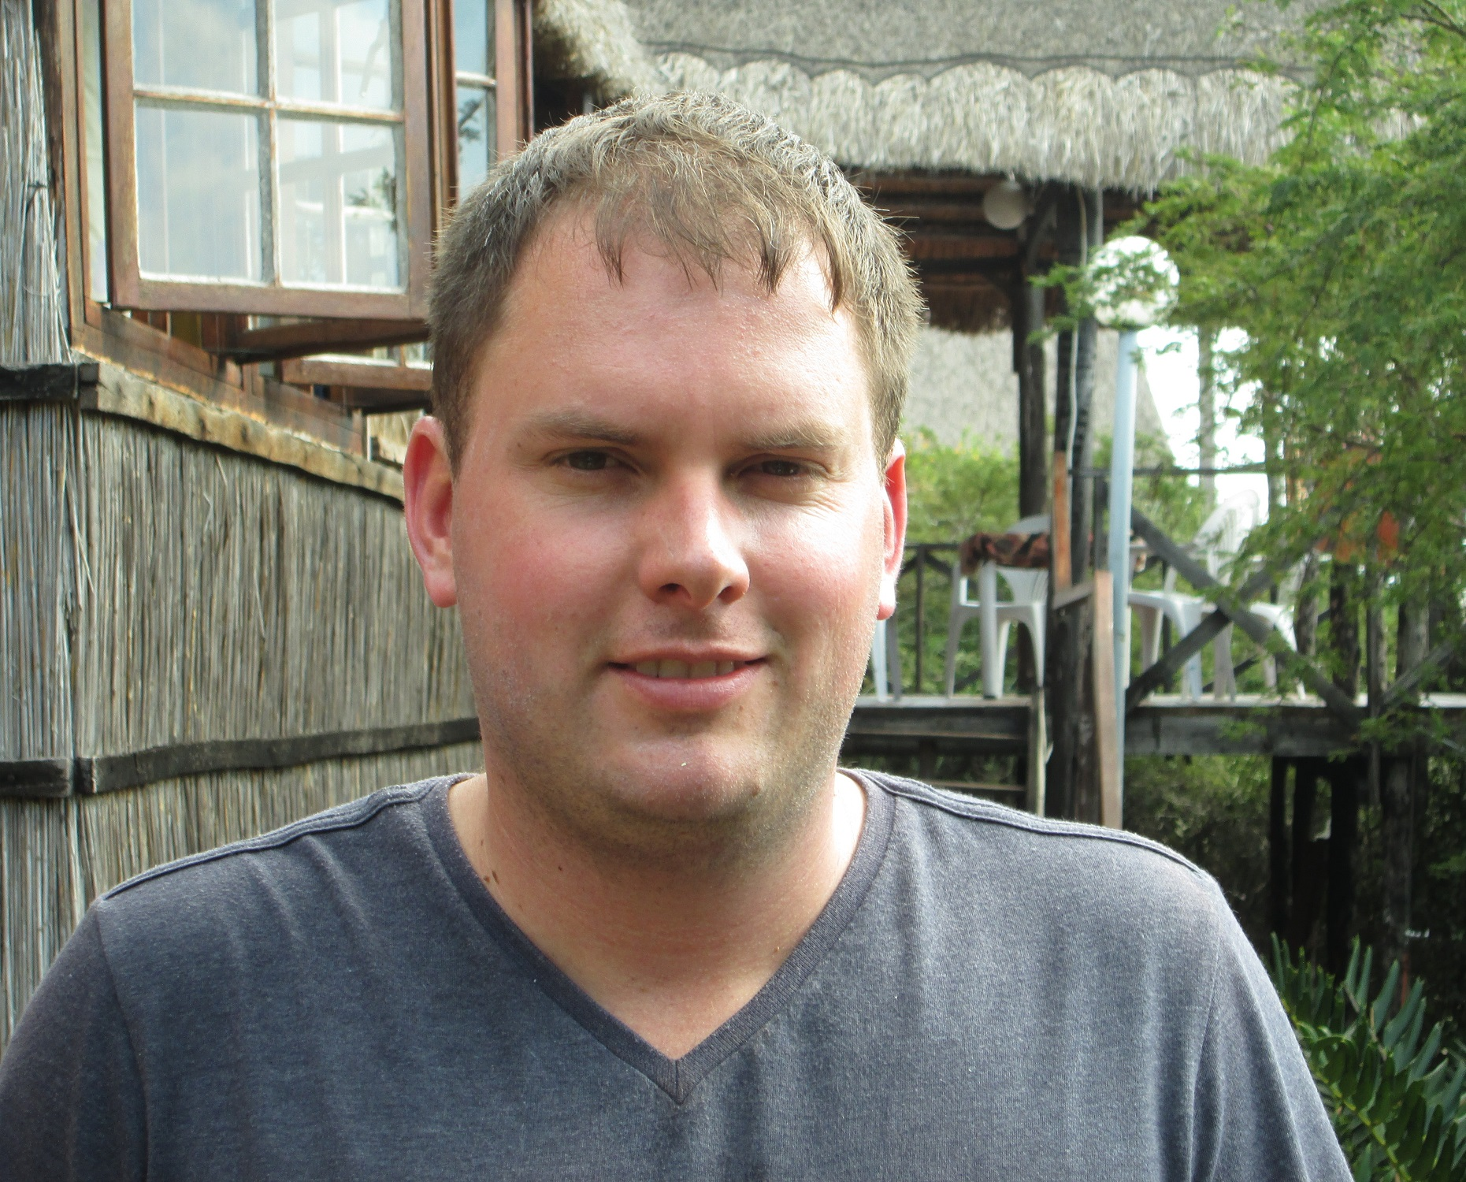

OCTOBER 2020

PERSONAL PARTICULARS

Full Name: David Alan
Surname: Read
I.D Number: 8504085089087
Date of Birth: 08/04/1985
Place of Birth: Sandton, Gauteng, South Africa
Nationality: South African
Gender: Male
Home Language: English
Marital Status: Married
Dependants: None
Postal Address: P.O Box 66732
Highveld
0169
South Africa
E-mail address: david.read@fabi.up.ac.za / readd@iafrica.com
Contact numbers: +27 83 325 9077

EDUCATION

2012-2015
Institution: University of Pretoria
Degree: PhD Microbiology
Promoter: Prof G. Pietersen
Thesis: Overcoming bias in Citrus tristeza virus (CTV) genotype detection and a population study of CTV within Southern African Star Ruby grapefruit orchards
Skills/Techniques: Next-generation sequencing, PCR, PCR protocol design, Sanger sequencing, virus taxonomy, PAGE gel electrophoresis, large plasmid manipulation.

2009-2011
Institution: University of Pretoria
Degree: MSc Microbiology
Promoter: Prof G. Pietersen
Thesis: Characterization of Citrus tristeza virus populations in grapefruit trees showing cross-protection breakdown and have been pre-immunised with two different cross-protection sources.
Skills/Techniques: PCR, cloning, Sanger sequencing, phylogenetics.

2008
Institution: University of Pretoria
Degree: BSc (Hons) Biotechnology.
Promoter: Prof G. Pietersen
Project title: Detection and quantification of Citrus tristeza virus, using real-time RT-PCR
Skills/Techniques: PCR, real-time PCR, in vitro transcription

2004-2007
Institution: University of Pretoria
Degree: BSc Biotechnology
Majors: Microbiology and Genetics

2003
Institution: Fourways High School
Matric. Senior Certificate with Endorsement

WORK EXPERIENCE AND OTHER POSITIONS

2009

Tutor for 1st year microbiology, Department of Microbiology, University of Pretoria

2011

Demonstrated practical aspects for the Honours techniques course, Department of Microbiology and Plant Pathology

Mentor for a second year undergraduate student in the Forestry and Agricultural Biotechnology (FABI), Centre for Tree Health Biotechnology (CTHB) mentorship program.

2012

Involvement in an international exchange visitor program at the United States Department of Agriculture, Agricultural Research Service (USDA-ARS) in Parlier, California. Tasks included various laboratory experiments and bioinformatics aimed at the completion of the ‘Candidatus Liberibacter africanus genome project.

Reference: Dr Hong Lin (hong.lin@ars.usda.gov)

2015

Involvement in an exchange visitor program at the Estación Experimental Agroindustrial Obispo Colombres (EEAOC) in Tucuman, Argentina. Over the period of a month, both field and laboratory work was carried out to determine the Citrus tristeza virus populations in commercial grapefruit and lemon trees in northern Argentina.

Reference: Beatriz Stein (bstein@sinectis.com.ar)

2012-2015
General laboratory and safety manager – Plant Virology Group, Department of Microbiology and Plant Pathology, University of Pretoria

Reference: Prof. Gerhard Pietersen (gpietersen@sun.ac.za)

2012-2013
Representative of the post-graduate student body of the Department of Microbiology and Plant Pathology, University of Pretoria, South Africa

Reference: Prof. Fanus Venter (Fanus.Venter@up.ac.za)

2016-2017
Institution: Centre for Microbial Ecology and Genomics, University of Pretoria
Hosts: Prof. D.A Cowan and Prof Y. Van de Peer
Capacity: Post-doctoral researcher. Analysis and comparison of metagenomic and metaviromic datasets of the taxonomic and functional diversity of microbial communities of the Namib Desert in Namibia.

Reference: Prof. Don Cowan (don.cowan@up.ac.za)

2017-2020
Institution: Agricultural Research Council – Biotechnology Platform
Hosts: Dr. Genevieve Thompson and Dr Dirk Swanevelder
Capacity: Postdoctoral researcher. Characterisation of viral populations associated with crop and ornamental plant species in east and southern Africa.

References: Dr. Genevieve Thompson (genevieve.d.thompson@gmail.com)
Dr Farai Muchadeyi (muchadeyif@arc.agric.za)
Dr Dirk Swanevelder (swanevelderd@arc.agric.za)

2020-2022
Institution: University of Pretoria – Forestry and Agricultural Biotechnology Institute (FABI
Hosts: Prof Emma Steenkamp and Prof Bernard Slippers
Capacity: Postdoctoral fellow. Plant virology

BURSARIES

Awarded the Citrus Research International (CRI) Prestigious Bursary for postgraduate studies.

Awarded the NRF Free-standing-Innovation Masters and Doctoral Scholarship 2014

Awarded the University of Pretoria postdoctoral fellowship 2016-2017

NRF KIC (Knowledge Interchange and Collaboration) for international travel to a conference in 2017.

DST NRF postdoctoral fellowship awarded for the period of 2017-2020.

ADDITIONAL COURSES

2008: Merck Laboratory Safety & Chemical Grades Seminar
2010: Certificate: Cape Wine Academy
2011: Diploma: Cape Wine Academy

AWARDS

Granted membership to the Golden Key International Honour Society for academic excellence.

SCIENTIFIC PRESENTATIONS

2008: Detection of Citrus tristeza virus using real-time RT-PCR. Presented at the 5th Citrus Research Symposium.

2010: Comparison of Citrus tristeza virus (CTV) strain population compositions in Grapefruit trees, pre-immunised with two different cross-protecting sources. Presented at the 6th Citrus Research Symposium

2011: Comparison of Citrus tristeza virus populations in Grapefruit trees, pre-immunized with two different cross-protecting sources. Presented at the 47th Congress of the Southern African Society for Plant Pathology. (Poster presentation).

2011: Strain diversity of Citrus tristeza virus (CTV), within South African red grapefruit trees in the field. Presented at the 2011 Congress of the South African Society for Microbiology

2012: CTV diversity in southern African grapefruit orchards and the improvement of cross-protection. Presented at the 7th Citrus Research Symposium.

2014: Diversity of Citrus tristeza virus (CTV) populations within commercial Southern African Star Ruby orchards. Presented at the 8th Citrus Research Symposium

2014: Diversity of Citrus tristeza virus (CTV) populations within commercial Southern African Star Ruby orchards. Presented at the DuPont Plant Breeding Symposium: Genomics of crops and pathogens for molecular breeding

2020: Use of RNA metaviromics for the discovery of viruses affecting staple crops in East Africa. Presented at the ARC-FAO training workshop for maize lethal necrosis disease.

Publications in ISI rated journals

Scott K.A., Hlela Q., Zablocki O., Read D., van Vuuren S. and Pietersen G. (2012). Genotype composition of populations of grapefruit-cross-protecting citrus tristeza virus strain GFMS12 in different host plants and aphid-transmitted sub-isolates. Archives of Virology. 158, 27-37

Read D. and Pietersen G. (2015). Genotypic diversity of Citrus tristeza virus within red grapefruit, in a field trial site in South Africa. European Journal of Plant Pathology. 153, 531-545

Lin H., Pietersen G., Han C., Read D.A., Lou B., Gupta G. and Civerolo E.L. (2015). Complete genome sequence of “Candidatus Liberibacter africanus,” a bacterium associated with citrus huanglongbing. Genome Announc 3(4):e00733-15. doi:10.1128/genomeA.00733-15

Read D.A., and Pietersen G. (2016). PCR bias associated with conserved primer binding sites, used to determine genotype diversity within Citrus tristeza virus populations. Journal of Virological Methods, 237, 107-113.

Read D.A., and Pietersen G. (2017). Diversity of Citrus tristeza virus populations in commercial ‘Star Ruby’ grapefruit orchards in Southern Africa, determined using Illumina MiSeq technology. European Journal of Plant Pathology, 148, 379–391

Read D.A., Palacios M.F., Foguet L., Kleynhans J., Figueroa J., Stein B. and Pietersen G. (2017). Survey of Citrus tristeza virus (CTV) strains in Citrus limon (L) Burm f. (Lemon) in Tucumán Province, Argentina. European Journal of Plant Pathology, 149, 1029–1039

Read D.A., Palacios M.F., Kleynhans J., Figueroa J., Foguet L., Stein B., and Pietersen G. (2018). Survey of Citrus tristeza virus (CTV) diversity in pigmented Citrus x paradisi (Macfad.) (Grapefruit) trees in north-western Argentina. European Journal of Plant Pathology, 151, 329–340

Read D.A., Palacios M.F., Figueroa J., Stein B., and Pietersen G. (2018). Survey of Citrus tristeza virus (CTV) on Citrus paradisi (Macfad.) cv. “Marsh” in South Africa.
European Journal of Plant Pathology, 151, 1101–1105

Read D.A., Featherston J., Rees D.J.G., Thompson G.D., Roberts R., Flett B.C., Mashingaidze K., Berger D.K., Welgemoed T., Pietersen G., Schulze S.E., Kiula Alois Kullaya B., Mbega E. (2018). First report of maize yellow mosaic virus (MaYMV) on maize (Zea mays) in Tanzania. Journal of Plant Pathology, 101, pp203

Read D.A., Featherston J., Rees D.J.G., Thompson G.D., Roberts R., Flett B.C., Mashingaidze K., Pietersen G., Kiula Alois Kullaya B., Mbega E. (2019). Diversity and distribution of Maize-associated totivirus strains from Tanzania. Virus Genes, 55, pp429-432
Read D.A., Featherston J., Rees D.J.G., Thompson G.D., Roberts R., Flett B.C., Mashingaidze K., Pietersen G., Kiula Alois Kullaya B., Mbega E. (2019). Characterization and detection of Maize-associated pteridovirus (MaPV), infecting maize (Zea mays) in the Arusha region of Tanzania. European Journal of Plant Pathology, 154, 1165-1170

Read D.A., Featherston J., Rees D.J.G., Thompson G.D., Roberts R., Flett B.C., Mashingaidze K., Pietersen G., Kiula Alois Kullaya B., Mbega E. (2019). Molecular characteriztion of Morogoro maize-associated virus, a nucleorhabdovirus detected in maize (Zea mays) in Tanzania. Archives of Virology, 164, 1171-1715

Read D.A, Muoma J and Thompson G.D (2020). Metaviromic analysis reveals coinfection of papaya in western Kenya with a unique strain of Moroccan watermelon mosaic virus and a novel member of the family Alphaflexiviridae. Archives of Virology, 165, 1231–1234

BOOK CHAPTERS

Read D.A and Pietersen G. (2019). Analysis of Genotype Composition of Citrus tristeza virus Populations Using Illumina Miseq Technology. In: Catara AF., Moshe B-J, Grazia L. (Eds.) Citrus Tristeza Virus: Methods and Protocols. Methods in Molecular Biology, doi: 10.1007/978-1-4939-9558-5

BIOGRAPHICAL SKETCH

I was born in Johannesburg, South Africa in 1985, to parents Michael and Nolene Read. I grew up on a small holding until my early 20s, which had a significant impact in sparking my interest in nature and natural phenomena, even from a young age. While growing up, I was exposed to keeping and maintaining livestock, small scale crop production as well keeping an aviary as one of my hobbies. Later on, I became very interested in the cultivation of cycads, orchids and various species of carnivorous plants, which is still a hobby that I currently maintain.

During my high school career I adopted a very keen interest in Chemistry and Physics. These were also the subjects in which I excelled, further broadening my interest in science in general. I have a keen interest in nature and natural phenomena and as a result chose to follow a career in the biological sciences. Upon completion of my matric year, I began my undergraduate career at the University of Pretoria, where I completed all of my tertiary education.

I have also had the privilege of gaining international laboratory experience when I was invited to be a guest researcher at the United States Department of Agriculture, Agricultural Research Service (USDA-ARS), San Joaquin Valley Agricultural Sciences Center, Parlier, California, United States. This was a 2 month visit from the start of February until the end of March 2012, under the supervision of Dr Hong Lin. During this period I contributed to the "Candidatus" Liberibacter africanus genome project, by performing gap closing between contigs using PCR and bioinformatics techniques.

During my postgraduate training with the Department of Microbiology and Plant Pathology, I gained a wealth of expertise in carrying out technical tasks in molecular biology. I performed these tasks with a meticulous attention to detail and ensure that they were carried out to completion, to the highest possible standard. This attention to detail extends beyond my professional capacity, to household responsibilities and recreational tasks as well.

During my postdoctoral career, I have gained a wealth of experience, especially around the generation and analyses of next generation sequencing data. During this time, I have also published a siginificant body of research in peer-reviewed journal, particularly in the field of plant virus epidemiology and virus discovery. During my tenure as a DST-PDP postdoctoral fellow at the ARC, I have been largely responsible for the management and running of various projects, as well as the supervision of an MSc candidate. This experience will serve both myself and potential employers well, as I look to further my research career.

My interests outside of scientific research include hiking, travelling and reading. I strive to make the most of my time and strike a balance between time spent on research and recreation.

REFERENCES

Prof Gerhard Pietersen
E-mail: gpietersen@sun.ac.za
Contact number: +27 82 647 5326 / +27 12 420 3265

Prof Jacques Theron
E-mail: Jacques.theron@up.ac.za
Contact number: +27 12 420 2994

Prof Fanus Venter
E-mail: fanus.venter@up.ac.za
Contact number: +27 12 420 4100

Prof Brenda Wingfield
E-mail: Brenda.wingfield@up.ac.za
Contact number: +27 12 420 6471

Dr. Genevieve Thompson
E-mail: genevieve.d.thompson@gmail.com
Contact number: +27 12 529 9227

Dr. Jasper Rees
E-mail: djg.rees@icloud.com
Contact number: +27 82 415 9295

Dr Dirk Swanevelder
E-mail: swanevelderd@arc.agric.za
Contact number: +2779 506 8617

Dr Farai Muchadeyi
E-mail: muchadeyif@arc.agric.za
Contact number: +2774 615 0000

